Unix And Shell Programming Lab
BTIT406
LINUX COMMANDS:
- pwd
command syntax: pwd
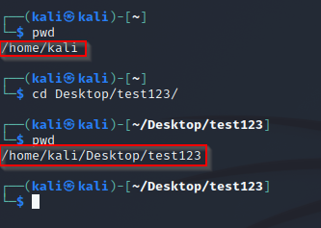
Note: after using ‘pwd’ you will get the location of current directory in your system
- cd
command syntax: cd [PATH OF DIRECTORY] …
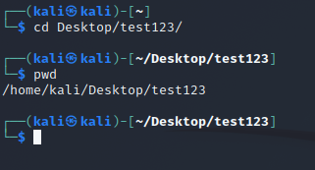
Note: “{path}” is the location of the directory in a system.
Note: to go back to the location “/home/kali/” then just enter the command ‘cd’
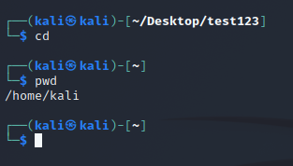
Note: to just move one directory back from the current directory like moving from “/home/kali/Desktop/test123” to “/home/kali/Desktop” just enter command ‘cd ..’ . now here “..” is used to go to the parent directory of the current directory.
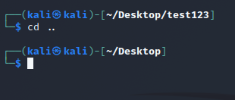
Note: to go to home directory we can either use ‘cd’ or use ‘cd ~’ . here ‘~’ signifies the home directory
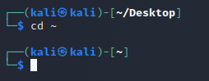
- who
command syntax: who [OPTIONS]… [FILE | ARG1 ARG2]
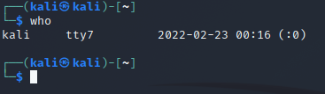
Note: displays the information about the users on the system
  - option ‘-b’
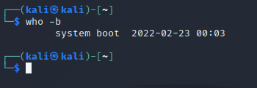
Note: ‘-b’ option with ‘who’ command displays the last boot time of the system
  - option ‘-H’
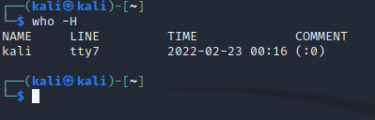
Note: displays the information about the users on the system with headings
  - option ‘-q’
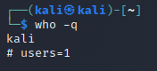
Note: displays all login names and number of users logged on the system
  - option ‘-a’
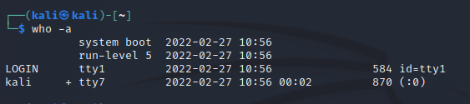
Notes: displays information same as -b -d --login -p -r -t -T -u

- whoami
command syntax: whoami [OPTION]...
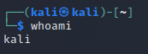
Notes: Print the username associated with the current effective user ID. Same as id -un.

- man
command syntax: $man [OPTION]... [COMMAND NAME] ...
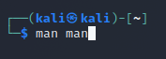
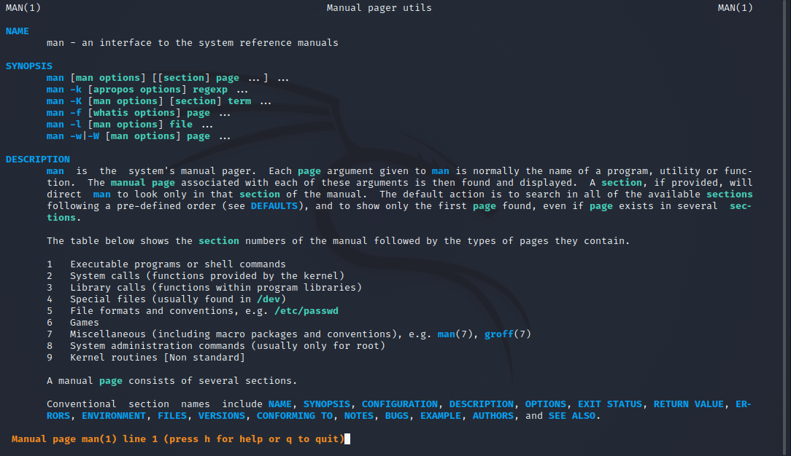
Notes: like a manual it displays all the information regarding a specific command with all the options information, etc.
- echo
command Syntax: echo [option] [string]

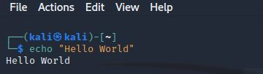
Notes: Display a line of text/string on standard output or a file

- option ‘-e’
NOTE: -e here enables the interpretation of backslash escapes

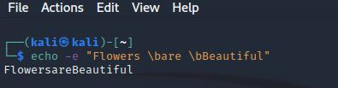
Notes: \b removes all the spaces in between the text

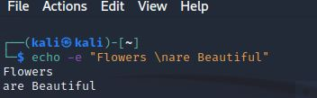
Notes: \n This option creates new line from where it is used

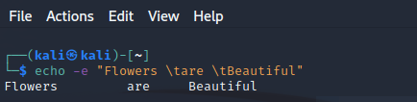
Notes: \t this option is used to create horizontal tab spaces

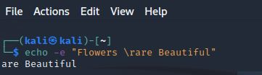
Notes: \r carriage return with backspace interpreter ‘-e‘ to have specified carriage return in output
- Cal
Command syntax: cal [ [ MONTH ] YEAR]
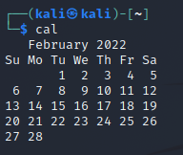
Notes: Display a simple calendar of the current month is displayed in traditional format.

- Option ‘-3’

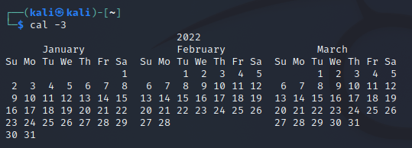
Notes: Display the previous, current, and next month surrounding today. Similarly, option ‘-1’ Display only the current month. This is the default. Display a calendar for the current year

- Option ‘-y’

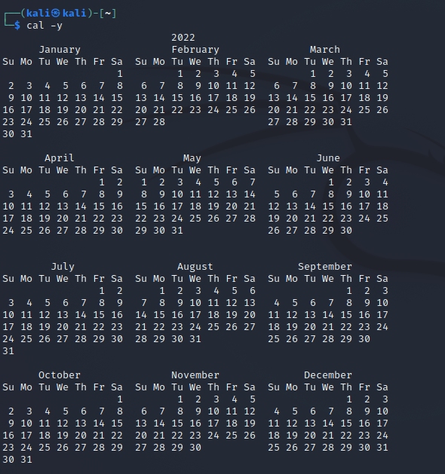
Notes: Display a calendar for the current year.

